***K8-P2***

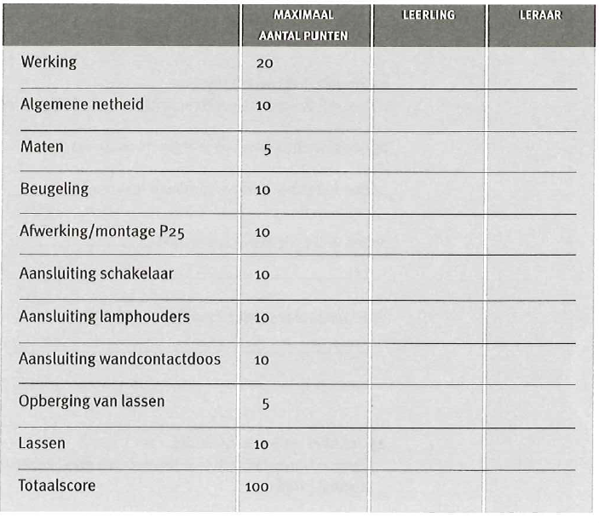Naam 1:_________________________________

Naam 2:_________________________________